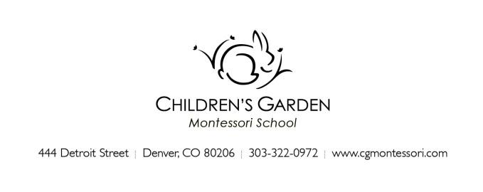

August 2019
Dear Parent,

As the summer heads into August, we are looking forward to the start of a new school year. We are pleased to introduce this year’s Toddler program teaching team and welcome you and your child to the classroom community!
If your child is new to the Toddler program, we will contact you to arrange for a home visit close to the start of school. This brief visit allows us to meet and begin getting to know your child in their most comfortable setting, as well as provide you an opportunity to discuss general questions you may have about the program, your child’s preparation, and your expectations. Your child may want to invite the teacher to see some of their favorite things or they may prefer to observe quietly while you talk! The visit should last no longer than 30 minutes.
*If there are sensitive or in-depth items to discuss we prefer to arrange an additional conversation time when your child is not present.

Please gather the following items ahead of the start of school: (For pick up at the home visit or email to toddlers@cgmontessori.com)
- 1 horizontal 4x6 photograph of your child, and 1 4x6 photograph of your family. These will be used to identify your child’s cubby and place in the classroom.
- A pair of inside shoes for your child to wear at school. We recommend sturdy shoes with a velcro closure. Foamtreads and Montessori Movers both make great inside shoes.
- Any health forms or paperwork for the office.

Please bring the following items for the first day of school:
- A small backpack with:
  - A change of weather-appropriate clothing (multiple changes if your child is practicing toilet independence)
  - Diapers
  - Wipes

Please label all clothing and belongings with your child’s name!

We look forward to our school year together!

Your Toddler Class Team,
AM Toddler class Kirsten Goode & Rachel Regan
PM Toddler class Kristen Blomgren & Rachel Regan
Support Beverly Jackson
toddlers@cgmontessori.com

