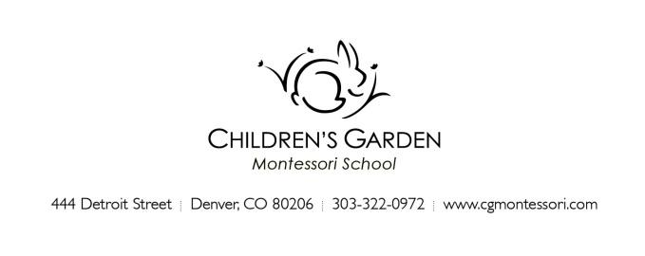
August 2022
Hello CG Toddler Family!

As the summer turns its way into August, we are looking forward to the start of a new school year. We are pleased to introduce this year’s Toddler program teaching teams and welcome you and your child to our school community! This is to bring you a few important things to know as you prepare for the weeks ahead.

If your child is new to the Toddler program, one of your child’s teachers will contact you to arrange for a home visit close to the start of school. This brief visit allows us to meet and begin getting to know your child in their most comfortable setting, as well as provide you an opportunity to broach any general questions you may have about the program, your child’s preparation, and your expectations*. Your child may want to invite the teacher to see some of their favorite things or they may prefer to observe quietly while you talk. The visit should last about 20-30 minutes.
*If there are sensitive or in-depth items to discuss we prefer to arrange an additional conversation time when your child is not present.

Some parents may prefer to have their home visit outdoors on a patio or yard. Please let your teacher know if this is your setting preference and if you would like for them to wear a mask for the visit when they contact you for scheduling. Teachers will get in touch with new Toddler student families about a home visit soon!!

Please gather the following items ahead of the start of school (for pick-up at a home visit or email to your classroom email (see below):
- 1 horizontal 4x6 photograph of your child, and 1 4x6 photograph of your family. These will be used to identify your child’s cubby and place in the classroom. Please do not send in a frame.
- A pair of inside shoes for your child to wear at school. We recommend crocs or natives. They are easy to clean and assist with toileting.
- Any health forms or paperwork for the office.
Please bring the following items for the first day of school:
- A small backpack with:
  - A change of weather-appropriate clothing (multiple changes if your child is practicing toilet independence)
  - Wet-bag
  - Diapers
  - Wipes
  - Optional: If your child will be mask wearing at school, please send a couple of extras for changing if needed during the school day. As of this writing the school does not require mask wearing except in specific circumstances which are communicated to those impacted on an as needed basis. These policies are subject to change according to public health recommendations. We will update families as needed throughout the year. Please see our website for COVID policies and practices.

--- Please label all clothing and belongings with your child’s name (yes, even the socks)! ---

Snacks are available to children during their daily sessions. The school will provide a snack for the first week of school and a rotation schedule for families will be sent home the week ahead of the start of school. Please talk with us if your child has a specialized diet, allergies and if you prefer to bring specific food items for your child.

School officially begins the week of August 29th with an Orientation schedule. Toddler children attend for a shorter time than usual the first week to help them ease into the change of routine. This first week is a “soft start” for the children, as is typical for the start of school at CGMS. Along with this letter you will have received a schedule for Orientation week with the abbreviated session times. As a reminder:
Toddler children attend on their regular enrolled days (aside from school closure days) for 1 ¾ hours.
- AM Classes attend 8:30 – 10:15 am
- PM classes attend 12:30 – 2:15 pm
We will start our regular schedule the following week (after Labor Day).

Meet and Greet is on Friday, August 26th. Plan to stop in with your child for a brief visit during the designated time. You do not need to stay the whole time. Rather than a social gathering, this is a time for teachers to show you and your child the environment before the first day of drop-off at the gate. Toddler sessions are timed such that those with children in both programs may first visit Primary before visiting Toddler. XP children and parents are welcome to come by during either their AM or PM class designated time.

Meet and Greet Schedule
- Primary AM (Ward-Hobbs and 440) classes: 9:00 to 10:00 am
- Toddler AM (2, 3 and 5 day) classes: 9:30 to 10:30 am
- Primary PM (Ward-Hobbs & 440) classes: 12:00 to 1:00 pm
- Toddler PM (2, 3 and 5 day) classes: 12:30 to 1:30 pm

We are not all business though! Plan to join us for the kick-off of the school year Family Picnic. Save the date for Wednesday, August 31st, 5:00 – 7:00 pm at Alamo Placita Park. More details in the School Newsletter.

Stay up to date. Your first 2022-23 School Newsletter is coming to your inbox soon! This informative email is sent weekly throughout the school year. Also, see the Parent section of the website for additional items including your Parent Handbook, which has lots of information you will want to read and refer to during the school year.

We look forward to our school year together!
Your Toddler Teaching Team

AM Toddler classes: Kristen Blomgren and Rose Hensen
PM Toddler classes: Kristen Blomgren and Rachel Regan
Support teachers: Leslie Green, Kirsten Goode, Beverly “BJ” Jackson
Studio: Angelina Lloyd & Amy Laugeson

Contact your Toddler Class Team
toddlers@cgmontessori.com

Additional contacts:
Bhowell@cgmontessori.com Bekke Howell, Head of School
Jboes@cgmontessori.com Jamie Boes, Associate Director
Cramey@cgmontessori.com Catherine Ramey, Office Administrator
info@cgmontessori.com Kirsten Goode, Administrative resource
Studio@cgmontessori.com Angelina Lloyd, Studio teacher and coordinator

