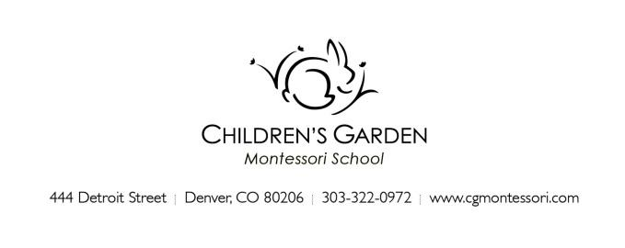
December 2022

Hello Children’s Garden Family!

We are pleased to introduce ourselves as your Primary program teaching teams and to welcome you and your child to our school community this winter! This is to bring you a few important things to know as you prepare for your child’s start of school in January.

As a family of a child who is new to the Primary program, one of your child’s teachers will contact you to arrange for a home visit close to the start of school. This brief visit allows us to meet and begin getting to know your child in their most comfortable setting, as well as provide you an opportunity to broach any general questions you may have about the program, your child’s preparation, and your expectations*. Your child may want to invite the teacher to see some of their favorite things or they may prefer to observe quietly while you talk. The visit should last about 20-30 minutes.
*If there are sensitive or in-depth items to discuss we prefer to arrange an additional conversation time when your child is not present.

Additionally, a Meet and Greet appointment will be made for your child to visit their new school environment with you. Plan to stop in for a brief look around.

Please gather the following items ahead of the start of school (for pick-up at a home visit or email to your classroom email (see below).
- 3 close-up photographs of your child, 4x6 vertical orientation. They will be used to identify your child’s cubby, studio attendance, and in a community installation to share our faces with our community.
- A pair of inside shoes for your child to wear at school. For safety and comfort, we recommend sturdy loafer, Mary Jane, Croc or Native type slippers which are not overly bulky. Anything that is easy for a child to put on and take off independently, and which fits well, to support gross motor navigation of the classroom.
- 2 complete changes of clothes for your child to keep at school (easy for your child to manage and change themselves).
- Any forms or paperwork for the office.
Children should bring to school:
- If your child will be mask wearing at school, please send a couple of extras for changing if needed during the school day. Labeled if non-disposable. As of this writing the school does not require mask wearing except in specific circumstances which are communicated to those impacted on an as needed basis. These policies are subject to change according to public health recommendations. We will update families as needed throughout the year. Please see our website for COVID policies and practices.
- Extended Primary (XP) children should bring a backpack packed with a lunch (and ice pack) in a reusable lunch box daily. (Half-day Primary children do not need to bring a backpack to school.)

--- Please label all clothing and belongings with your child’s name so we can help them keep track! ---

Snacks are available to children during their daily sessions. The school will provide a snack for the first week of school and a rotation schedule for families will be sent home the week ahead of the start of school. Please talk with us if your child has a specialized diet, allergies and if you prefer to bring specific food items for your child.

Please review all school policies in your parent handbook, especially those related to health and well-being. We abide by strict wellness policies to help us ensure a safe environment for our students and our community.
Use this link to the Parent Handbook or on the website >Parents>forms and information.

School resumes classes after the winter break beginning Wednesday, January 4th, with Tuesday as a work day for teachers and staff.

New students begin with an Orientation schedule. Primary children attend 2 days during Orientation week. This first week is a “soft start” for the children, as is typical for the start of school at CGMS.

Stay up to date. The weekly School Newsletter is coming to your inbox soon! This informative email is sent each Friday throughout the school year. Also, see the Parent section of the website for additional items including your Parent Handbook, which has lots of information you will want to read and refer to during the school year.

We look forward to our school year together!
Your Primary Teaching Team

440AM/PM/XP class: Claire Jackson, Samantha Matthews, Irina Mitchell-assistant
WHAM/PM/XP class Michelle Bower, Meghan Robertie, George Michael Karas
Support teachers: Kirsten Goode, Beverly Jackson
Studio: Angelina Lloyd, Amy Laugeson

Contact your Primary class team:
440am@cgmontessori.com
wham@cgmontessori.com

Additional contacts:
Bhowell@cgmontessori.com Bekke Howell, Head of School
Jboes@cgmontessori.com Jamie Boes, Associate Director
Cramey@cgmontessori.com Catherine Ramey, Office Administrator
Studio@cgmontessori.com Angelina Lloyd, Studio teacher and coordinator
info@cgmontessori.com Kirsten Goode, Administrative resource

