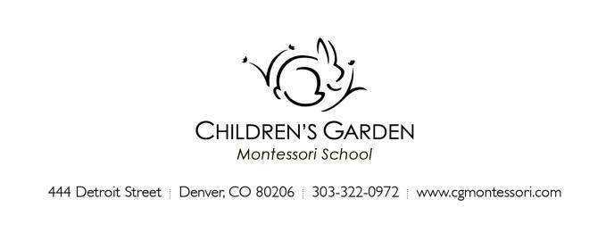

December 2022
Hello CG Toddler Family,

We are pleased to introduce ourselves as your Toddler program teaching team and to welcome you and your child to the Toddler classroom community this winter! This is to bring you a few important things to know as you prepare for your child’s start of school in January.

If your child is new to the Toddler program, we will contact you to arrange for a home visit close to the start of school. This brief visit allows us to meet and begin getting to know your child in their most comfortable setting, as well as provide you an opportunity to discuss general questions you may have about the program, your child’s preparation, and your expectations. Your child may want to invite the teacher to see some of their favorite things or they may prefer to observe quietly while you talk! The visit should last no longer than 30 minutes. *If there are sensitive or in-depth items to discuss we prefer to arrange an additional conversation time when your child is not present.

Additionally, a Meet and Greet appointment will be made for your child to visit their new school environment with you. This will take place on the first day of your child’s school schedule, at the end of the class session. Plan to stop in with your child for a brief visit.

Please gather the following items ahead of the start of school: (For pick up at a home visit or send email to toddlers@cgmontessori.com)
- 1 horizontal 4x6 photograph of your child, and 1 4x6 photograph of your family. These will be used to identify your child’s cubby and place in the classroom. Please do not send in a frame.
- A pair of inside shoes for your child to wear at school. We recommend crocs or natives. They are easy to clean and assist with toileting.
- Any health forms or paperwork for the office.
Please bring the following items for the first day of school:
- A small backpack with:
  - A change of weather-appropriate clothing (multiple changes if your child is practicing toilet independence)
  - Wet-bag
  - Diapers
  - Wipes
  - Optional for children under 3-years-old: 2 clean masks for wearing at school.

**Please label all clothing and belongings with your child’s name (even the socks)!**

Snacks are provided on a rotating basis by class families. A rotation schedule for families is sent home ahead of each month. Please talk with us if your child has a specialized diet, allergies and if you prefer to bring specific food items for your child.

Please review all school policies in your parent handbook, especially those related to health and well-being. We abide by strict wellness policies to help us ensure a safe environment for our students and our community.
Use this link to the Parent Handbook or on the website >Parents>forms and information.

School resumes classes after the winter break beginning Wednesday, January 4, with Tuesday as a workday for teachers and staff.

New Toddler children begin with an Orientation Schedule:
- Their first scheduled day will be a Meet and Greet appointment at the school with teachers, parent, and child. This is a time to acquaint your child with their new school setting.
- Next the child attends the rest of their first week on their regular enrolled days for a shorter time than usual to help them ease into the new routine.
Orientation Times:
- AM class: 8:30 – 10:15 am
- PM class: 12:30 – 2:15 pm

Stay up to date. The weekly School Newsletter is coming to your inbox soon! This informative email is sent each Friday during the school year. Also, see the Parent section of the website for additional items including your Parent Handbook, which has lots of information you will want to read and refer to during the school year.

We will contact you to confirm the Home Visit, Meet & Greet and Orientation schedule for you and your child.

We look forward to our school year together!

Your Toddler Class Team
toddlers@cgmontessori.com

AM Toddler class Kristen Blomgren and Rose Jorden
PM Toddler class Kristen Blomgren and Leslie Green
Support Beverly Jackson, Kirsten Goode
Studio Angelina Lloyd & Amy Laugeson

Additional contacts:
Bhowell@cgmontessori.com Bekke Howell, Head of School
Jboes@cgmontessori.com Jamie Boes, Associate Director
Cramey@cgmontessori.com Catherine Ramey, Office Administrator
info@cgmontessori.com Kirsten Goode, Administrative resource
Studio@cgmontessori.com Angelina Lloyd, Studio teacher and coordinator

